Contents
Document Change Control 1
Details of WABA Integration 2
Flowchart Create Template 3
Flowchart Send Template Message 4
Outbound – Business Initiated 5
Send Outbound Message 6
Message Template Status Webhook 6
Inbound – Customer Initiated 7
Receive Message 8
Reply Customer 8

Document Change Control
Any change in the document shall be incorporated in the below tables.
Version # | Date | Revised By | Reason for change
1.0 | 27/6/2023 | Khiu | Initial Document

Details of WABA Integration

Email | mybillone@nubitel.co
Password | 23w1LLch4!
WABA ID | 137835906073454
WABA NAME | BillOne Technology Sdn Bhd
WABA PHONE | +60 11-1061 7770
WABA PHONE ID | 116466391558534
WABA GUID | a3793d4f-3b21-461c-97b5-5369588f1611

Flowchart Create Template

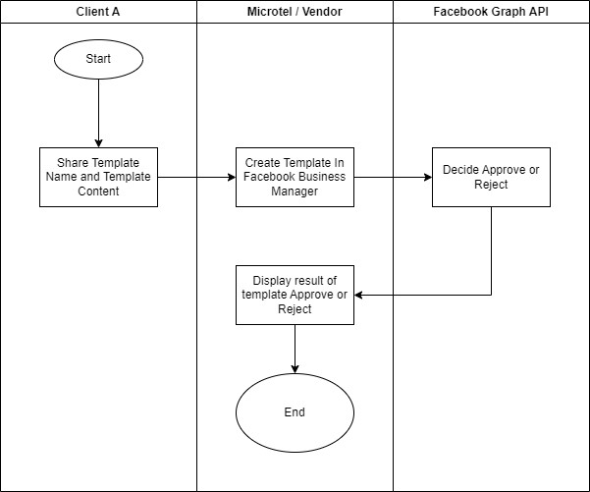

Flowchart Send Template Message

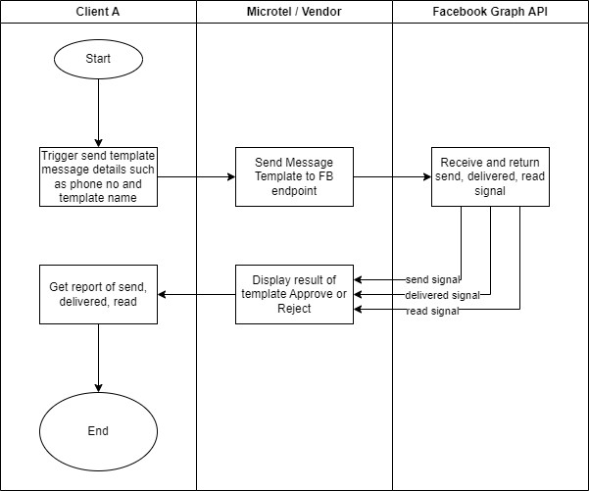

Outbound – Business Initiated

Send Outbound Message

Step 1: Authenticate

Step 2: Sync the message template from Meta.

Step 3: Send the message template to customers.

Message Template Status Webhook

Step 1: Authenticate

Step 2: Create Webhook to receive the message status.
Important: Create one webhook only no matter inbound or outbound

Step 3: Sample JSON of webhook
- Sent
  - Message send from API reached WhatsApp Meta Server
  - One grey tick in WhatsApp
- Delivered
  - Message send from WhatsApp Meta Server to Customer
  - Two grey ticks in WhatsApp
- Read
  - Message read by customer.
  - might NOT getting this status if customer disable read receipt.
  - Two blue ticks in WhatsApp

Inbound – Customer Initiated

Receive Message

Step 1: Authenticate
Step 2: Create Webhook to receive the customer status.
Important: Create one webhook only no matter inbound or outbound

Step 3: Sample JSON Webhook when customer message

Step 4: Getting Attachment (Image, Video, Document and etc)

Reply Customer

Step 1: Authenticate

Step 2: Reply Customer

